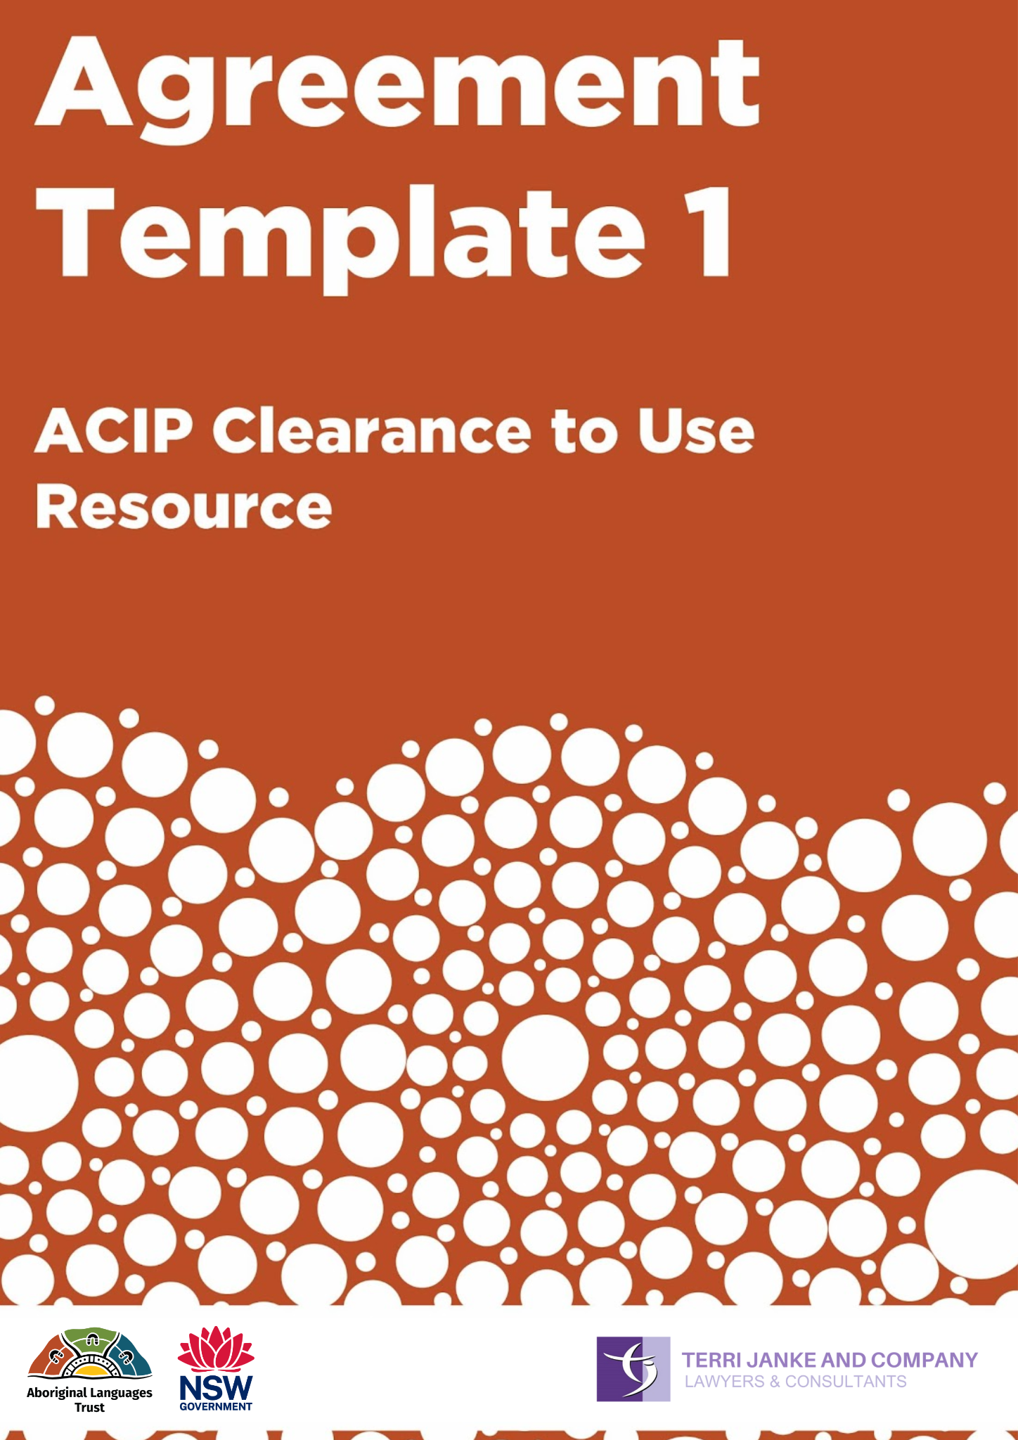

About this Agreement template
What is this Agreement for?
This Agreement is used to record permission from an Aboriginal Custodian to use Language, Knowledge or Culture that is contained in existing material e.g. books, films, recordings or photographs.
The person or organisation seeking permission to use the material will also need to get permission from the copyright owner.
You can find more information about this Agreement on page 21 of the Community Guidelines: Protecting your Cultural and Intellectual Property.
Who should sign this Agreement?
This Agreement should be signed by an Aboriginal Custodian with cultural authority to give permission for others to use the ACIP contained in the material.
The Aboriginal Custodian who gives permission may be an Elder or other person with cultural authority to speak for the ACIP in the material. In the case of old films or photographs, it may be a family member of the person who is in the film or photograph
Discussion with Elders or other people in the Aboriginal Language group may be necessary to determine the proper person to give consent. In some cases, it may be a representative – such as the chairperson of an Elders council.

Cultural Clearance to Use Existing Resource in Project

GIVEN BY:
Name
Address
Community
“I” or “me” or “Cultural Custodian”
TO:
Name
Address
“the Licensee”
The Project
- [INSERT DETAILS OF THE PROJECT] (the Project).
- The Licensee has identified the following material for use in the Project and/or adaptation into a new teaching and learning resource in the Project:
Name/title of Resource:
(the Resource)
Author/creator:
Copyright holder
(if different from the author/creator)
Publisher:
Year of publication (if known)

Use of Language, Knowledge or Culture in the Resource
- The Resource contains the Language Knowledge or other Knowledge, Culture (stories, songs, artwork, and/or photographs) which belongs to me, my family, group, clan or nation. We are the owners and custodians of this Language, Knowledge or Culture and have the right to speak for it, control how it is used, and protect it.
- The Licensee seeks my permission to use (and allow others to use) the Language or other Knowledge or Culture contained in the Resource as part of the Project, and for this purpose to:
  - edit and adapt the Resource for use as a teaching and learning resource;
  - copy, publish and share the Resource;
  - make copies of the Resource available to students, teaching staff or other members of the community; and
  - edit and adapt the Resource into a new teaching and learning resource.
- The Licensee has explained to me that the Resource, including the Language, Knowledge or Culture contained within it, may be available and visible to a large number of people e.g. storing copies in archives.
- The Licensee is committed to protecting and upholding the rights of Aboriginal peoples to their Languages, Knowledge and Culture. The Licensee will follow the Aboriginal Language Trust’s Guidelines for the ethical and respectful use of Aboriginal Languages in NSW (the Guidelines), which guides the use of my Language and Culture Knowledge in the Project.
If the Resource is used as source material for a new teaching and learning resource
- I understand that the Licensee (or its employees or contractors) may use the Language and Culture Knowledge in the Resource and adapt it, to create new Language material (New Material). If the Licensee does this, I will not own any right, title or interest in the New Material.
- I understand that the Licensee will consult with me and show me a final version of the New Material which is produced using the Resource, before it is published. This is so that I have the opportunity to give feedback on the New Material including an opportunity to provide feedback on any spelling or grammatical errors made in the New Material.
Attribution
- When using the Resource the Licensee will attribute me or other relevant owners or custodians of the Language, Knowledge and Culture in the Resource according to the information supplied below:
Name:
Group or Nation:
Any other details:
Benefits
- I will receive the following benefits in exchange for my consent to the Licensee’s use of the Language, Knowledge and Culture in the Resource:
  - if the Licensee adapts the Resource into New Material, a copy of the new teaching and learning resource free of charge; and
  - where relevant, permission to use the New Material for my own non-commercial purposes.
Cultural Mourning Protocol
- In the event of my passing, the Licensee can consult with my Nominated Representative about whether a cultural mourning protocol applies to the use of my name, image, voice or biographical information and how this can best be respected.
- My Nominated Representative is:
Name:
Email:
Phone:
Relationship to me:
My agreement
- I agree to the Licensee’s use of the Resource in the Project on the terms and conditions of this deed. I promise that I have the cultural authority (including permission from traditional owners where required by cultural protocol or customary law) to grant the permission to the Licensee to use this Resource for the purposes outlined in this deed.
- I agree that there is nothing in the Language, Knowledge or Culture in the Resource which is culturally inappropriate to share or which is likely to offend any Aboriginal person or community. The Resource is suitable to be shared with a wide audience.
- I promise to disclose to the Licensee, to the best of my knowledge, if there is anything which may affect or restrict how the Resource should be used and distributed.

EXECUTED AS A DEED:
SIGNED, SEALED AND DELIVERED by the Licensee:

Signed by Authorised Signatory | Signed by Witness or Authorised Signatory
Name of Authorised Signatory | Name of Witness or Authorised Signatory
Date | Date

SIGNED, SEALED AND DELIVERED by the Cultural Custodian:

Signature | Signed by Witness
Name | Name of Witness
Date | Date

