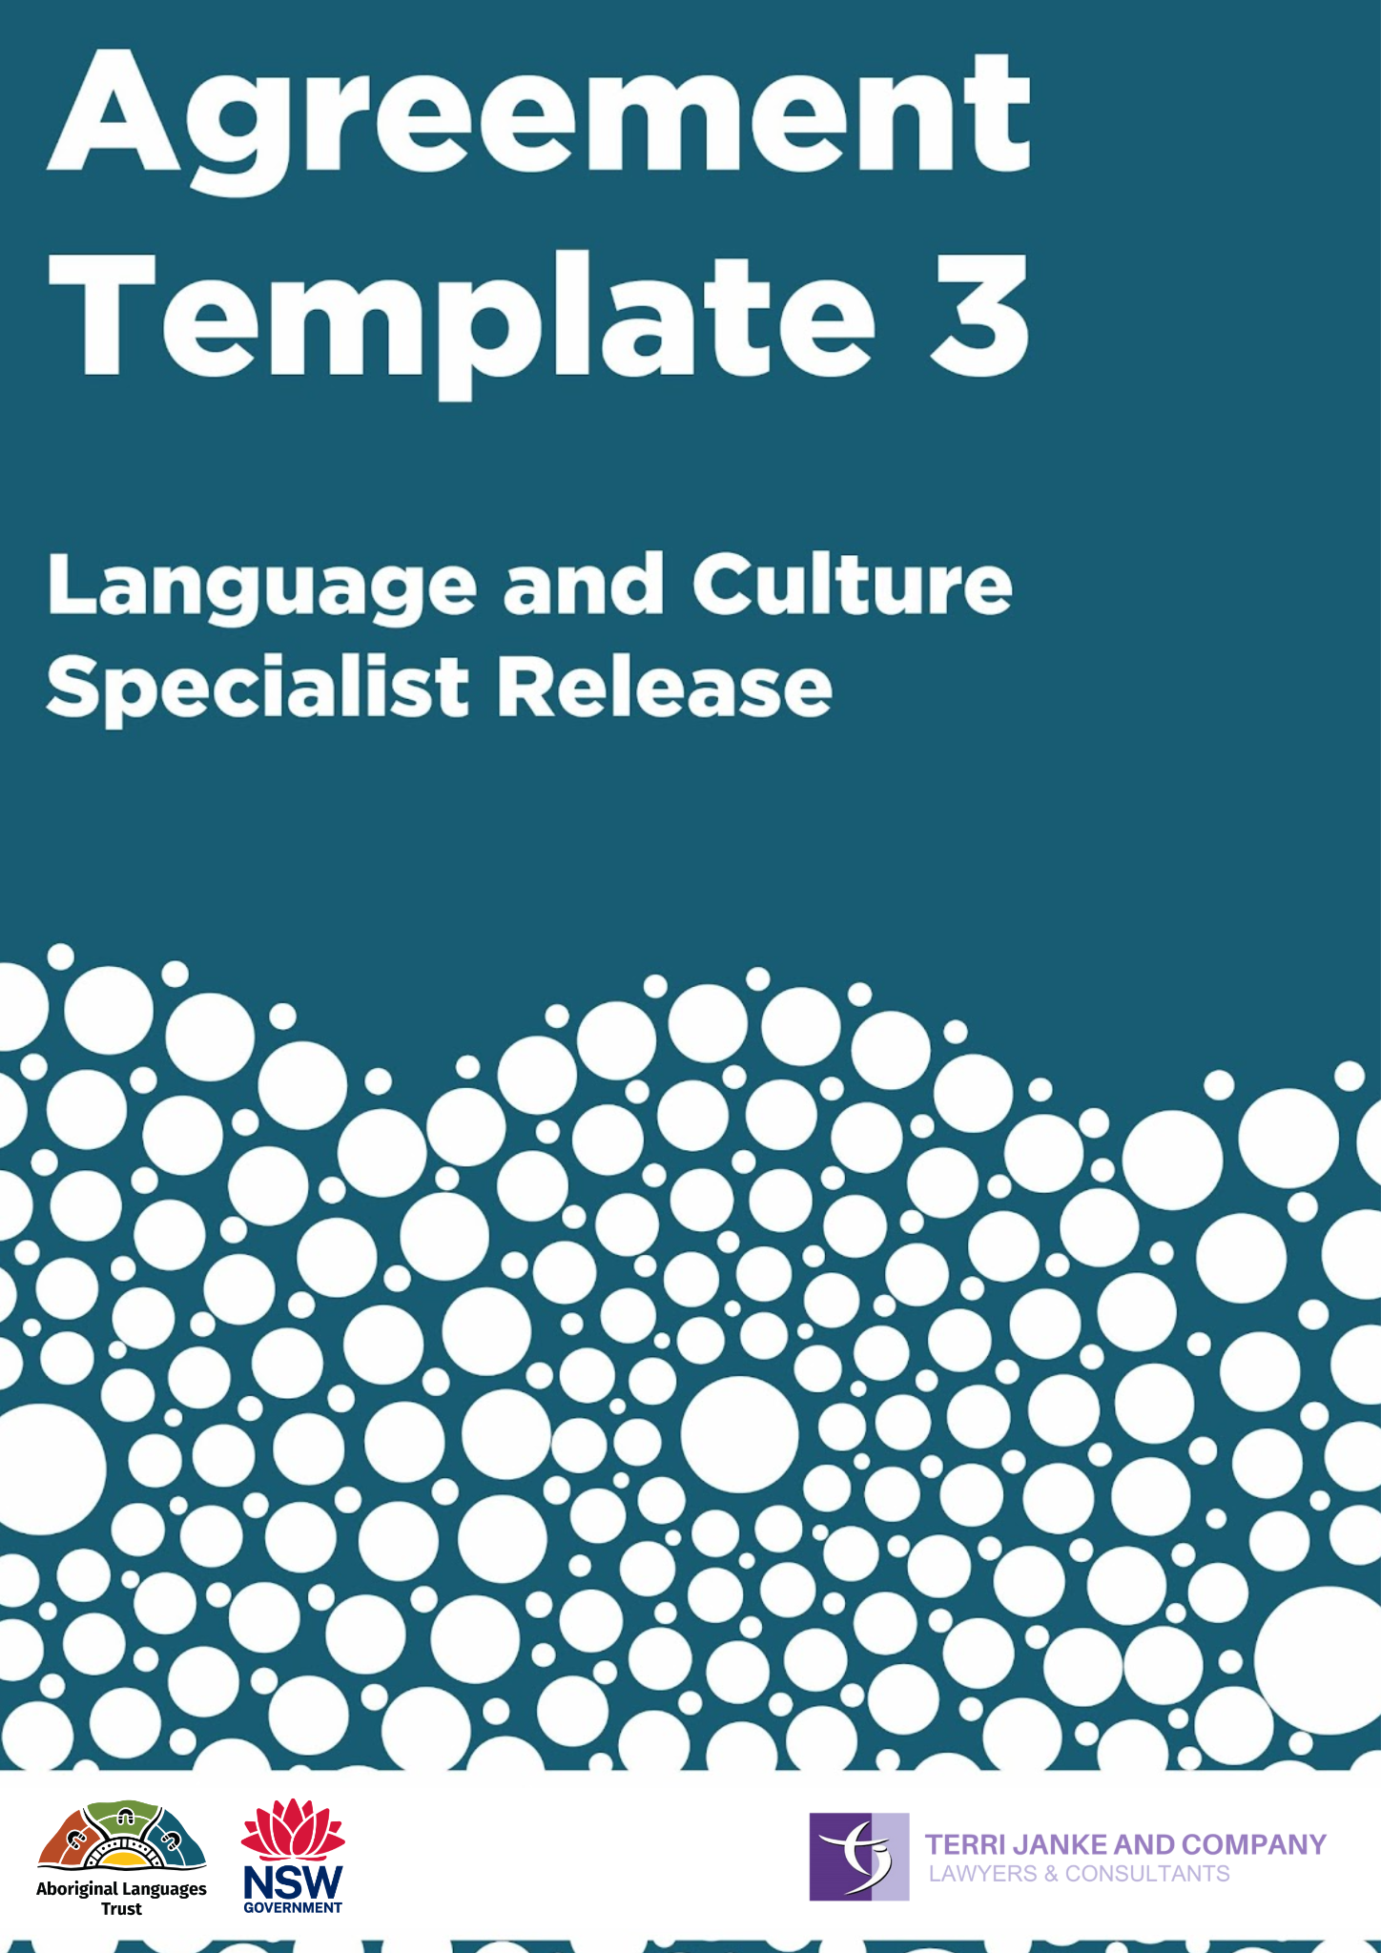

About this Agreement template
What is this Agreement for?
This Agreement is used in circumstances where a Language and Cultural Specialist agrees to share their knowledge of Language and Culture. They may wish to use this Agreement to feel a level of comfort that the Aboriginal Cultural and Intellectual Property (ACIP) shared while being recorded is protected. The ACIP is protected by maintaining their ownership and control of any ACIP shared by giving them ownership and control over the recording. Meanwhile, the person recording is given a license to use the recording in particular ways listed in the Agreement.

You can find more information about when to use this Agreement on:
- page 9 and 21 of the Community Guidelines: Protecting your Cultural and Intellectual Property; or
- page 11 of Working with Aboriginal Language Custodians: Guidelines for ethical and respectful collaborations.

Who signs this Agreement?
The Aboriginal person who shares their Language, Knowledge and Culture is referred to as the Language and Culture Specialist.

The person or organisation recording the Language and Culture Specialist is known as the Project Collaborator. This person may be an Aboriginal person who is coordinating their own Language project. Often the Project Collaborator will be an Aboriginal organisation, and the individual recording the Language and Culture Specialist works for the Project Collaborator. For example, a non-Aboriginal support worker (such as a linguist or researcher) may be asked to record a Language and Culture Specialist as part of their work for an Aboriginal Language organisation. In this case, the Project Collaborator is the organisation.

Language and Culture Specialist Release

GIVEN BY:
Name
Address
Language Group
“I” or “me” or “Language and Culture Specialist”
TO:
Name
ABN
Address
“the Project Collaborator”
The Project
- [INSERT DETAILS OF THE PROJECT] (the Project).
- I have been asked to share my Language and Culture Knowledge for use in the Project.
- I agree to the Project Collaborator [if the collaborator is an organisation, include: its employees or contractors] recording my Language and Culture Knowledge for use in the Project on the terms of this Language and Culture Specialist Release.
Protocols to protect Aboriginal Cultural and Intellectual Property
- I understand that the Project Collaborator will follow the Aboriginal Language Trust’s Guidelines for the ethical and respectful use of Aboriginal Languages in NSW (the Guidelines), which guides the use of my Language and Culture Knowledge in the Project. I have been given an explanation of the Guidelines and/or a copy of the Guidelines, before signing this Language and Culture Specialist Release.
Permission to record
- I agree to share my Language and Culture Knowledge with the Project Collaborator [if the collaborator is an organisation, include: or its employees or contractors] for the purposes of the Project.
- I give the Project Collaborator permission to film, record, photograph or otherwise make a record of my name, voice, image, biographic information, Language Knowledge, and other cultural Knowledge I choose to share.
- I give the Project Collaborator permission to make audio recordings, audio-visual recordings, transcripts of my words and any other written notes of my discussion with them. Collectively, these will be referred to as the Recordings.
Ownership of the Recordings
- I understand that I own copyright in the Recordings. The Project Collaborator hereby assigns all right, title and interest in the recordings to me.
- I understand that the [Aboriginal Language group of the Language and Culture Specialist] People will retain rights to any communally owned Cultural Knowledge including Language Knowledge used or referred to the in the Recordings.
Use of the Recordings
- I give the Project Collaborator a non-exclusive, royalty free, irrevocable, worldwide licence in perpetuity and in all media, to use, edit and adapt the Recordings including to use the Recordings:

  - How is the Project Collaborator allowed to use the Recordings? List purposes here, for example:
  - as language and culture teaching resources for use in the Project; and
  - to adapt the Recordings and the Language and Cultural Knowledge contained in the Recordings to create a new Language and Culture teaching resource for use in the Project.
- I understand that if the Project Collaborator adapts the Recordings to create a new Language resource or other material (New Language Material), then the Project Collaborator will be the owner of all right, title and interest in the New Language Material.
How the Recordings will be shared and stored
- I understand that the Recordings, or parts of the Recordings, or the New Language Material, may be published, including online. This means they could have a worldwide audience.
- I consent to the long-term storage and archiving of the Recordings with a national archive such as the National Film and Sound Archive or the Australian Institute for Aboriginal and Torres Strait Islander Studies, or at some other location by agreement with the Project Collaborator.
- I understand that if the Project Collaborator wishes to use the Recordings or the teaching and learning resources produced using the Recordings, for any other purpose, including commercial purposes, that they must seek my written permission.
Involvement and Consultation
- I understand that the Project Collaborator will consult with me and show me a final version of any New Language Material before it is published or finalised. This is so that I have the opportunity to give feedback on the New Language Material and make suggestions for editing and amending the New Language Material. This includes an opportunity to provide feedback on any spelling or grammatical errors made in the Recordings or in the New Language Material.
- The Project Collaborator will use its best endeavours to consult with me and involve me regarding the ongoing and future use of the New Language Material.
Benefits for the Language and Culture Specialist
- I will receive the following benefits in exchange for sharing my Language and Culture Knowledge with the Project Collaborator, and participating in the Project:
  - Payment of $[amount] per hour/ $[amount] per half day/ $[amount] per full day;
  - A copy of the Recordings free of charge;
  - Permission to use the Recordings for my own non-commercial Cultural maintenance use; and
  - [include any other agreed benefits].
Attribution
- When using the Recordings, and in the New Language Material, the Project Collaborator will attribute me and the [insert Language group of the Language and Culture Specialist] according to the information supplied below:
Name:
Nation/Language Group:
Any other details:
- I will let the Project Collaborator know if I do not wish to be attributed.
My promises
- I promise that I have the cultural authority (including permission from traditional owners where required by cultural law) to share my Language and Cultural Knowledge and to grant the permission to the Project Collaborator under this deed.
- The Project Collaborator has explained that the Recordings and/or the New Language Material may be available and visible to a large number of people e.g. incorporated into published materials or held in archives. I confirm that it is suitable to share my Language and Culture Knowledge with a wide audience.
- I agree that there is nothing in my Language or Culture Knowledge that I am sharing which is culturally inappropriate to share or which is likely to offend any Aboriginal or Torres Strait Islander person or community.
- I promise to disclose to the Project Collaborator, to the best of my knowledge, if there is anything which may affect or restrict how my Language or Culture Knowledge should be used or shared.
Succession and Cultural Mourning Protocol
- In the event of my passing, my Nominated Representative is authorised to make decisions about use of the Recordings and advise the Project Collaborator as to whether a cultural mourning protocol applies to the use of my name, image and voice, biographical information and how this can best be respected.
- My Nominated Representative is:
Name:
Address:
Email:
Phone:
Relationship to me:

EXECUTED AS A DEED:
SIGNED, SEALED AND DELIVERED by the Project Collaborator:

Signed by Authorised Signatory | Signed by Witness
Name of Authorised Signatory | Name of Witness
Date | Date

SIGNED, SEALED AND DELIVERED by the Language and Culture Specialist:

Signed by Language and Culture Specialist | Signed by Witness
Name of Language and Culture Specialist | Name of Witness
Date | Date

